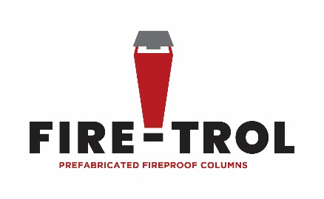
SAMPLE SPECIFICATION
Project Name:
Project Number:
CSI Master Format Location 05 12 00 – Structural Steel Framing
05 12 13 – Architecturally-Exposed Structural Steel Framing
05 12 16 – Fabricated Fireproof Steel Columns
PREFABRICATED BUILDING COLUMNS
A. General: Prefabricated fireproof columns consist of load-bearing structural-steel member encased in manufacturer's insulating material for fire protection and enclosed in an outer non-load-bearing steel shell. If the load-bearing structural steel member is an HSS square or round it will be filled with concrete.
1. Concrete Fill: Manufacturer's standard-mix structural concrete, with a minimum 28-day compressive strength of 4000 psi, machine mixed and mechanically vibrated during placement to produce concrete fill free of voids.
B. Fire-Resistance Ratings: Provide prefabricated building columns listed and labeled by UL or other third-party testing laboratory acceptable to authorities having jurisdiction for ratings indicated, based on testing according to ASTM E 119.
1. Fire-Resistance Rating X106 (2-hour rating)
2. Fire-Resistance Rating X104 (3-hour rating)
3. Fire-Resistance Rating X101 (4-hour rating)
C. Column Configuration: Provide columns of sizes and shapes indicated. Fabricate connections to comply with details shown or as required to suit type of structure indicated and fabricator Qualifications:
D. Manufactures Qualifications:
1. A qualified structural steel fabricator who participates in the AISC Quality Certification Program and is designated an AISC-Certified Plant, Category BU.
2. Qualify procedures & personnel according to AWS D1.1 – Structural Welding Code-Steel.
E. Manufacturers: Subject to compliance with requirements, provide prefabricated fireproof columns by one of the following:
1. Basis of Design: Fire Trol Columns
2. George H. Dean Inc.: Subject to matching BOD make parameters.
3. BlackRock: Subject to matching BOD make parameters.
4. Other approved equal manufacturer
F. Surface Preparation: Clean surfaces to be painted. Remove loose rust, loose mill scale, and spatter, slag, or flux deposits. Prepare surfaces according to SSPC specifications as follows:
1. SSPC-SP 2
G. Priming: Immediately after surface preparation, apply primer according to manufacturer’s instructions and at rate recommended by SSPC to provide a dry film thickness of not less than 1.5 mils. Use priming methods that result in full coverage of joints, corners, edges, and exposed surfaces.
H. Primer: Primer approved for use with Architect’s specified finish paint. See Section 09 91 00 “Painting.”

